**Data Exploration – Decision Tree (File- Organics)**

**The following are screenshots of the steps that are performed on the dataset :**

**Data Prediction**

1) How many leaves are in the optimal tree?

**Desition tree**

2) Which variable was used for the first split? What were the competing splits for this firstsplit?

g. Add a second Decision Tree node to the diagram and connect it to the Data Partition node.

**Desition tree**

Set the model roles for the analysis variables as shown above.

3) How many leaves are in the optimal tree?

The three way split has 33 leaves.

h. Based on the average square error, which of the decision tree models appears to be better?

From the above outputs Decision tree 2 is a better model, as with three-way splits has the lower validation average square error.

Lesson 4

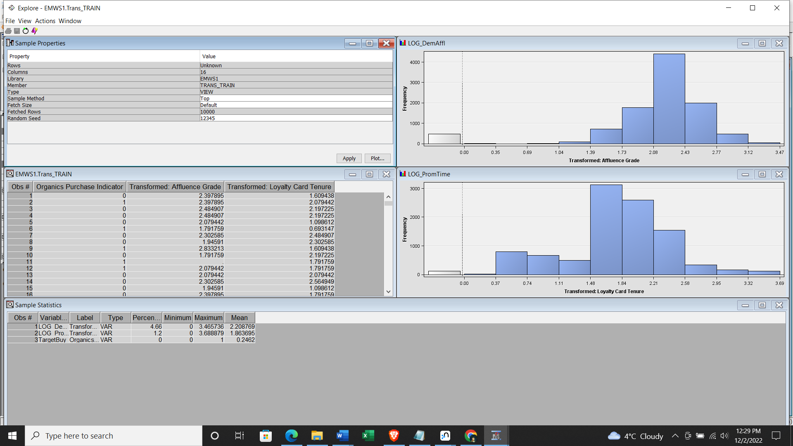

**Result – Decision Tree SAS organic Diagram**

